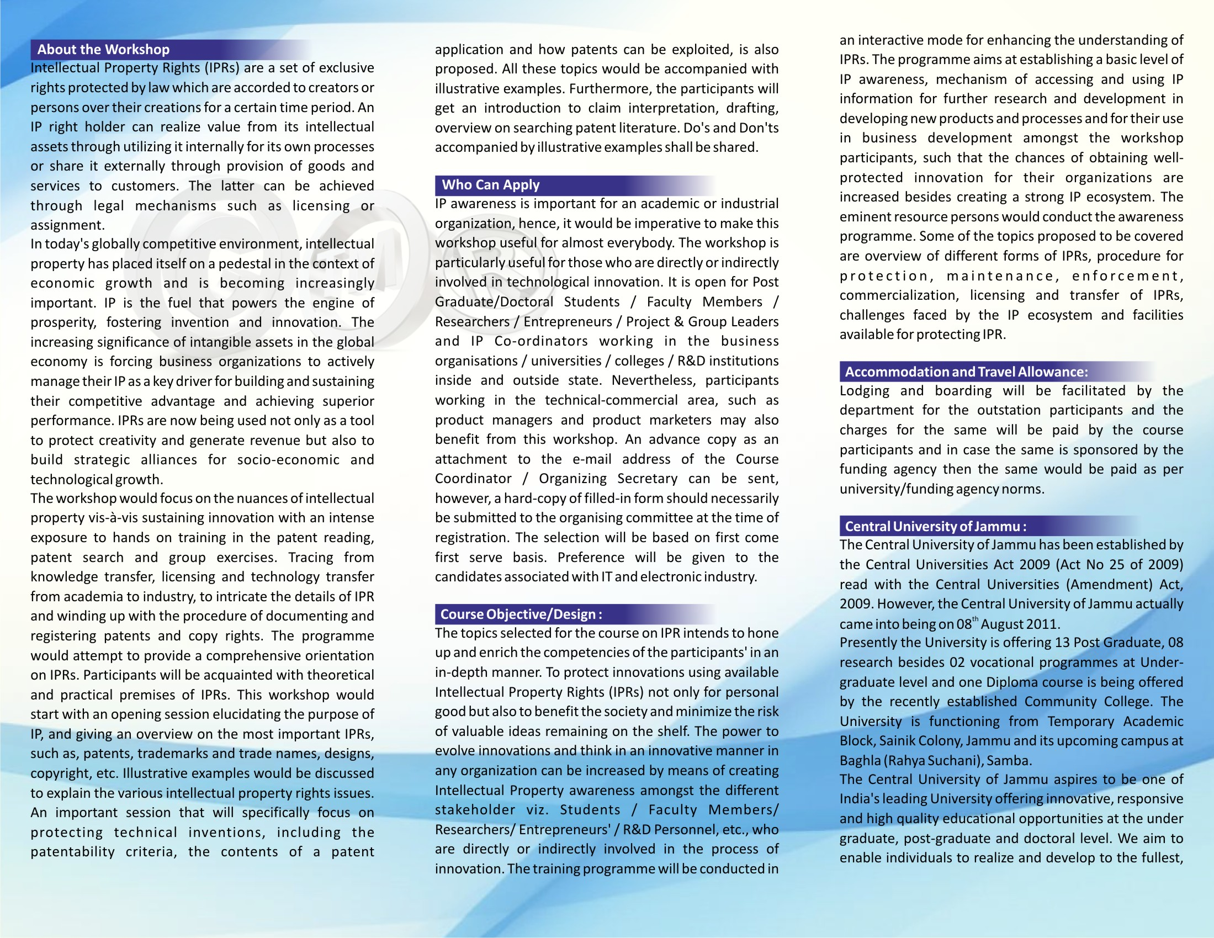
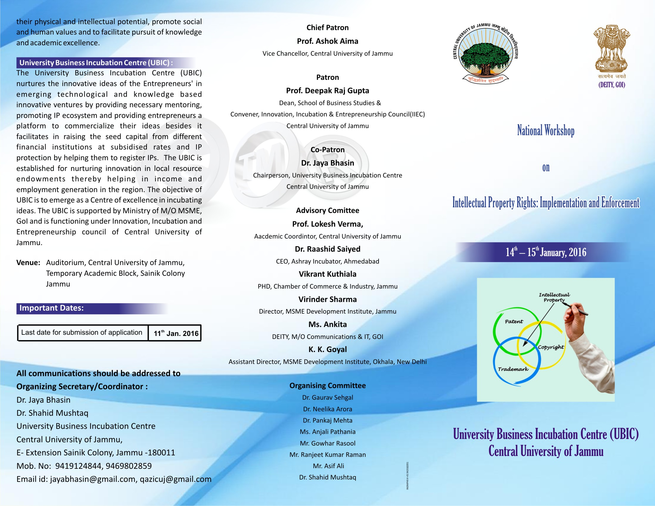
National Workshop on
Intellectual Property Rights : Implementation and Enforcement
14th – 15th , January 2016

Registration Form
S. No. | Particulars | Details
1. | Name of the Participant
2. | Sex
3. | Category | Academic/Industry
 |  | Gen/ST /SC /OBC /PH /Minority
4. | Department
5. | University/Organisation
6. | Mailing Address  (only departmental address required)
7. | Mobile No.
8. | E-mail
9. | Accommodation | Yes/No
Signature of the Applicant

Undertaking by Concerned Authority

This is to certify that (Mr/Ms) _______________________ is a ____________________in the Department of _______________________. I have no objection to permit him/her for the 2 day aforesaid National Workshop at Central University of Jammu.

(Sign & Seal)

