International Webinar on Climate Change and Sustainable Agriculture Concludes at Department of Botany, CUJ
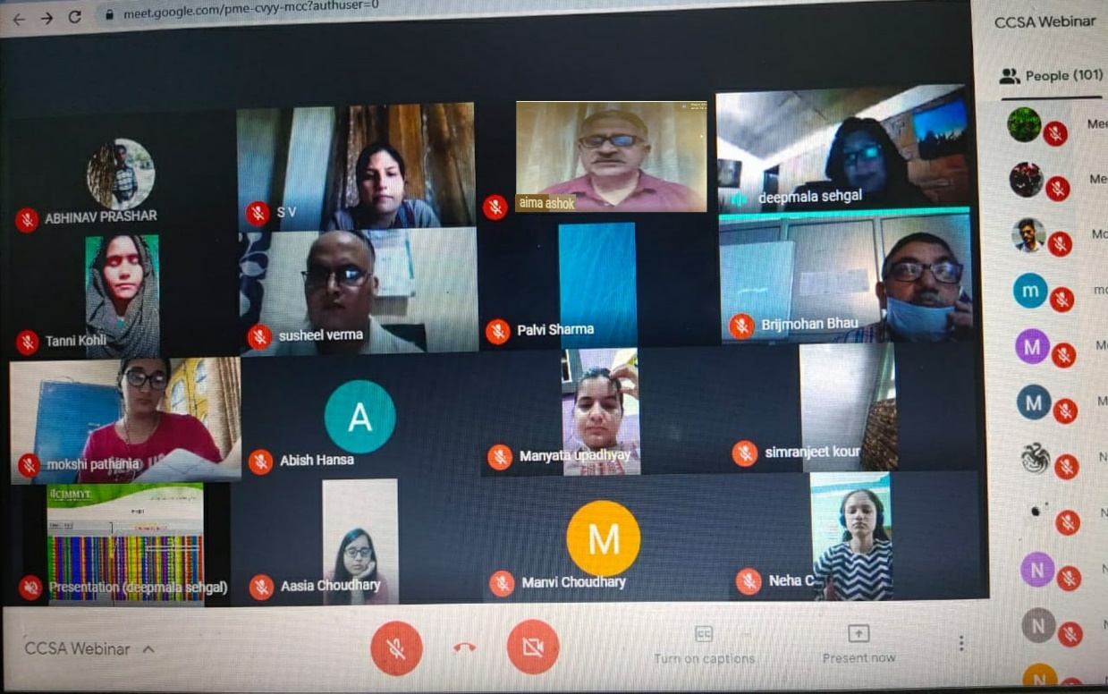

Samba, June 13: A two-day International Webinar on Climate Change and Sustainable Agriculture (CCSA-2020) organized by Department of Botany, Central University of Jammu concluded here on Saturday. The Webinar was inaugurated on Friday by Prof Ashok Aima, Vice Chancellor, Central University of Jammu. During his inaugural address he underscored the importance of discourse on sustainable agriculture, particularly in view of the Covid crisis faced by the whole world and the degradation of environment in recent years. He expressed his satisfaction and congratulated the Head, Department of Botany and Convenor of webinar, Prof. B. S. Bhau and the organizing team for their initiative of organizing a webinar on a contemporary topic by inviting resource persons from different countries and expressed confidence that all participants in general, and students of CUJ in particular, will be primed for this area of study. Prof. B. S. Bhau while welcoming the participants applauded them for registering in such large number for the webinar, and urged them to incorporate the takeaways from the deliberations in their academic pursuit.
The Dean, School of Life Sciences Prof. Deepak Pathania said that Department of Botany has provided an excellent academic platform to the participants to listen to and interact with experts of international repute.
Apart from the overseas delegates from USA, Mexico, Egypt and Thailand, around 270 researchers, faculty and students from 20 states in India participated actively in the webinar. The proceedings were conducted by organizing secretaries, Dr. Samantha Vaishnavi and Dr. Deepak Kumar actively supported by volunteers, Aditya Singh, Harsimerpreet Kour, Akanksha Sharma and Dr. Meenakshi Raina.
The invited speakers on the first day set the tempo for the deliberations. Dr. Deepmala Sehgal, Wheat Geneticist and QTL Deployment Coordinator, International Maize and Wheat Improvement Centre (CIMMYT), Mexico, discussed the properties of various molecular markers and their applications, while Dr. Mohamed Abdallah A. M. Gad, Wheat Diseases Research Department, Agricultural Research Institute, Giza, Egypt talked about the impact of climate change on wheat in Egypt. On the second day, Dr. Shalu Jain, Scientist North America Trait Assessment, Department of Pathology, Entomology and Nematology, Syngenta Seeds, St. Stanton, USA elaborated on modern genomic tools to enhance agriculture production. Dr. Bhabesh Dutta, Associate Professor, Extension Vegetable Disease Specialist, Department of Plant Pathology, University of Georgia, USA discussed the various aspects of management of bacterial pathogens of onion through genomic and applied research. Dr. Rupesh Kumar Mishra, Associate Professor, Ramalingaswami Fellow at Amity Institute of Biotechnology, Amity University, Jaipur gave a very informative talk on development of nanobiosensors being used in agriculture and plant sciences. The organizers acknowledge the support of all speakers, participants, students and CUJ administration and technical staff in the successful conduct of the webinar in these difficult times. The success of the webinar could be gauged by the overwhelming response by the participants.

