S.NO | NAME | PARENTAGE | Reg / Roll No | DOB | DOA | CAT. | STATE | GENDER | Date of M.Phil Submissionn | Religion | Name of Supervisior | PhD Thesis Title
1 | Preeti Gupta  (Part Time Ph.D) | Kuldip Raj Gupta  Sunita Gupta | 0150118 | 27-01-1986 | 18-12-2018 | Gen | J&K | Female | 18-12-2018 | Hindu | Dr. Susanta Nag | Intrahousehold Dynamics, Bargaining Power and Health Care: An Empirical Analysis
2 | Anil Kumar Bharti  (Part Time Ph.D) | Sardari Lal Bharti  Darshana | 0150119 | 04-08-1984 | 03-07-2019 | SC | J&K | Male | 03-07-2019 | Hindu | Dr. Susanta Nag | Intergenerational Transmission of Human Capital and Occupational Mobility: An Empirical Analysis
3 | Harmeet Kour | Ichpal Singh  Divinder Kour | 0250120 | 15-02-1993 | 23-02-2021 | Gen | J&K | Female | 23-02-2021 | Sikh | Dr. Susanta Nag | Household Vulnerability to Climate Change and Adaptation Strategies: A case Study of Ramban District in J&K. | 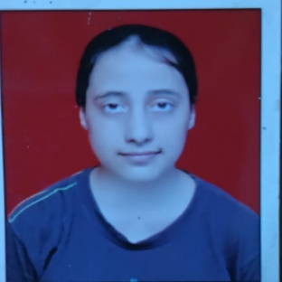
4 | Ananya Khajuria | Suresh Kumar Khajuria  Reeta Dogra | 0350120 | 21-01-1997 | 23-02-2021 | Gen | J&K | Female | 23-02-2021 | Hindu | Dr. Shaveta Kohli | Factors Influencing Development and Sustainability of Agricultural Marketing Cooperatives in India: A comparative Analysis of Northern States | 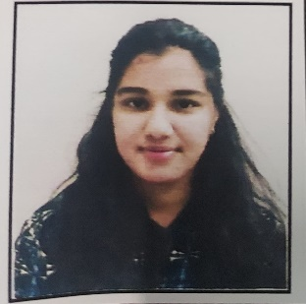
5 | Sumaya Jan | Gul Mohd Hajam | 0550120 | 15-12-1991 | 01-03-2021 | OBC | J&K | Female | 01-03-2021 | Muslim | Dr. Susanta Nag | Institutional Quality, Tourism Demand and Economic Growth: Evidence from BIMSTEC Countries | 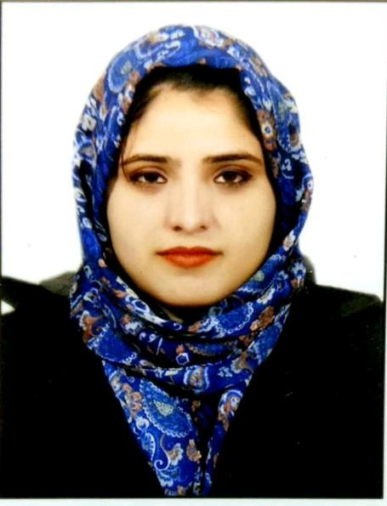
6 | Ritu | Sh. Ramavtar  Smt Sunita Devi | 0150122 | 05-09-1998 | 02-08-2022 | EWS | Haryana | Female |  | Hindu | Dr. Shaveta Kohli | Completed course work | 