Building Academia- Industry Bonds through Interaction Session at Department of MSCM
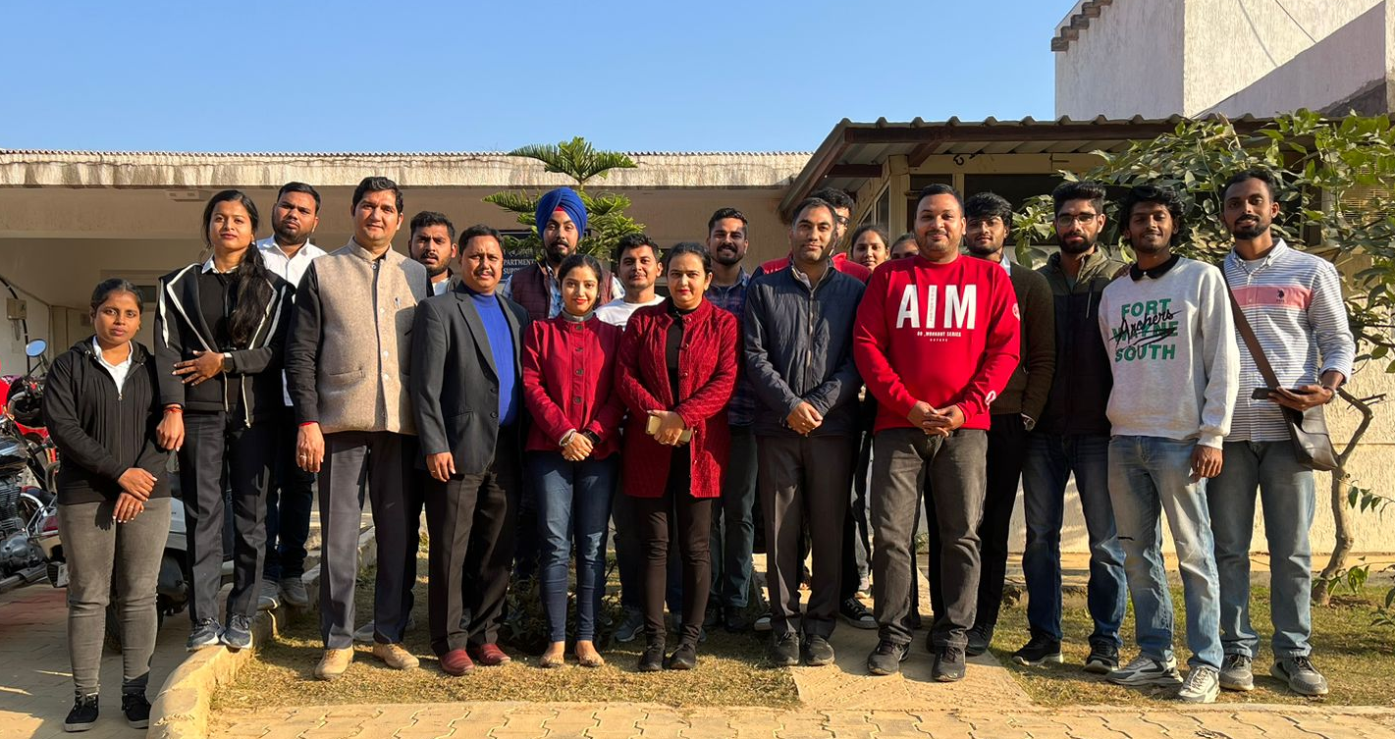

With the objective of strengthening bond between industry and academics, the Department of Marketing and Supply Chain Management (MSCM) heartily organized an interaction session with Dr. Saurabh Krishna, faculty, IHM Aurangabad on 22 November 2022. Dr. Naresh Sharma introduced the guest to the students in presence of Dr. Shahid Mushtaq, Head I/c, Department of MSCM. With a vast experience of 14 years in both academics & industry, Dr. Saurabh opened employment frontiers and possible work options for MBA (Marketing Management) students as entrepreneurs, effective job providers and nation builders. He highlighted the essence of moving away from the ideology of job seekers and accentuate the spirit of becoming job providers. Dr. Saurabh Krishna emphasized the urge of work- life balance and its necessity in corporate life beautifully citing real world examples with which the students could immediately connect. Dr. Anju Thapa applauded the conceptualization of the interaction session and facilitated the question answering round. The interaction session closed with a vote of thanks by Dr. Salil Seth who glamourized the session take-ways with a student-centric approach.

