Course File

Name of the Faculty: Dr. Ranvir Singh
Name of the Course: Rural and Urban Community Development
Course code:
Semester: MA Social Work Semester II
Academic year 2024-2025

Syllabus
- Course Title: Rural and Urban Community Development
- Course Credits: 04
- Course Learning Outcomes (CLOs):
  - Acquire advance understanding of tenets of Rural and Urban community development.
  - Identify distinct challenges of rural and urban communities.
  - To develop an insight on the policies, programmes and interventions by Governmental and Non-Governmental Organisations.
  - To relate the problems of poor and marginalized within the broader developmental context.

Unit I: Rural Communities
- The Village: Social perspectives; Gandhi and Ambedkar.
- Rural Development: History, Concept and Philosophy.
- Panchayati Raj and Development Programmes (73rd Amendment).
- Rural Mobilization: Concept; Agrarian Movement, Cooperative Approach; Farmers cooperative; Land Reform; Rural Credit.
Unit II: Rural Development and Interventions
- Determinants of Rural Development: Infrastructure, Poverty, Health, Sanitation, Employment, Education.
- Dynamics of Rural Society: Caste, Class, Tribe and Gender relations.
- Structural Inequality and Rural Poverty: Land Ownership/entitlements and Indebtedness.
- Rural Development Policies and Programmes: Impact Assessment of Livelihood, Education, Health, Skill Development, Sanitation, Land Acquisition programmes.
Unit III: Understanding Urban Community
- Urban Communities: Types and Features.
- Urbanization: Historical Formulation, Causes and Consequences.
- Urban Planning.
- Urban Governance: 74th Constitutional Amendment.
Unit IV: The Urban Poor
- Urban poor: Identity and Location.
- Challenges and Options for the Urban Poor: Housing, Labor Participation and the Unorganized Sector.
- Urban Basic Services for the Poor: Employment, Basic Needs, Sanitation, Education, Health and Shelter.
- Impact of Liberalization, Privatisation and Globalisation (LPG) on Urban Poor.
Unit V: Common Issues of the Communities
- Human Rights and Marginalized in India: (Children, Women, Minorities, Indigenous Population, Refugees, Dalits, Persons with Disability).
- Social Work Practice with Victims of Human Rights Violations: Illustration through Case Studies.

References / Suggested Readings
The document lists 13 key references, including works by:
- Arvind, K. (1999): Social inequalities in rural areas.
- Bhattacharya, B. (2006): Urban development in India.
- Byrne, D. (2005): Social Exclusion.
- Desai, A. R. (2012): Rural Sociology in India.

Lecture no | Topic covered | status
1 | The Village: Social perspectives | Achieved
2 | Gandhi Perspective | Achieved
3 | Ambedkar Perspective | Achieved
4 | Rural Development: History | Achieved
5 | Concept and Philosophy | Achieved
6 | Panchayati Raj | Achieved
7 | Development Programmes (73rd Amendment) | Achieved
8 | Rural Mobilization: Concept | Achieved
9 | Agrarian Movement | Achieved
10 | Cooperative Approach; Farmers' Cooperative | Achieved
11 | Land Reform; Rural Credit. | Achieved
12 | Determinants of Rural Development | Achieved
13 | Infrastructure, Poverty | Achieved
14 | Health, Sanitation | Achieved
15 | Employment, Education | Achieved
16 | Dynamics of Rural Society | Achieved
17 | Caste, Class, Tribe | Achieved
18 | Gender relations | Achieved
19 | Structural Inequality | Achieved
20 | and Rural Poverty | Achieved
21 | Land Ownership/entitlements | Achieved
22 | Indebtedness | Achieved
23 | Rural Development Policies and Programmes | Achieved
24 | Impact Assessment of Livelihood | Achieved
25 | Education Policies and Programmes | Achieved
26 | Skill Development Policies and Programmes | Achieved
27 | Sanitation Policies and Programmes | Achieved
28 | Land Acquisition programmes Policies and Programmes | Achieved
29 | Health Policies and Programmes | Achieved
30 | Urban Communities: Types and Features | Achieved
31 | Urbanization: Historical Formulation | Achieved
32 | Causes and Consequences | Achieved
33 | Urban Planning | Achieved
34 | Urban Governance | Achieved
35 | 74th Constitutional Amendment | Achieved
36 | Urban poor: Identity and Location | Achieved
37 | Challenges and Options for the Urban Poor: | Achieved
38 | Housing, Labor Participation for the Urban Poor | Achieved
39 | Unorganized Sector for the Urban Poor | Achieved
40 | Urban Basic Services for the Poor | Achieved
41 | Employment, Basic Needs | Achieved
42 | Sanitation | Achieved
43 | Education | Achieved
44 | Health and Shelter | Achieved
45 | Impact of Liberalization on Urban Poor | Achieved
46 | Privatisation on Urban Poor | Achieved
47 | Globalisation (LPG) on Urban Poor | Achieved
48 | Human Rights and Marginalized in India: (Children, Women, Minorities, Indigenous | Achieved
49 | Human Rights and Marginalized in India (Children, Women | Achieved
50 | Human Rights of Marginalized Indigenous Peoples in India | Achieved
51 | Human Rights of Marginalized Minorities in India | Achieved
52 | Refugees Human Rights | Achieved
53 | Dalits Human Rights | Achieved
54 | Persons with Disability Human Rights | Achieved
55 | Social Work Practice with Victims of Human Rights | Achieved
56 | Human Rights Violations: Illustration through Case Studies | Achieved
57 | Revision | Achieved
58 | Revision | Achieved
59 | Revision | Achieved
60 | Revision | Achieved
61 | Revision | Achieved

Question paper
RURAL AND URBAN COMMUNITY DEVELOPMENT
Time: 3 Hours
Maximum Marks: 100

Section A (Very Short Answer Questions)
(10 × 2 = 20 Marks)
Attempt all questions.
- Define rural community.
- What is Panchayati Raj?
- State any two features of rural development.
- What is rural mobilization?
- Define urbanization.
- What is urban governance?
- Who are urban poor?
- What is LPG in economic context?
- Define social inequality.
- What is human rights violation?

Section B (Short Answer Questions)
(Answer any 5 questions, each 6 marks = 30 Marks)
- Explain Gandhi’s perspective on village development.
- Discuss Ambedkar’s views on rural society.
- Describe the 73rd Constitutional Amendment.
- Explain determinants of rural development.
- Discuss caste and class dynamics in rural society.
- Explain the causes of urbanization.
- What are the features of urban communities?
- Discuss challenges faced by the urban poor.
- Explain land reforms in India.
- Write a note on human rights of marginalized groups.

Section C (Long Answer Questions)
(Answer any 4 questions, each 12.5 marks = 50 Marks)
- Discuss rural development in India: history, concept, and philosophy.
- Analyze rural development programmes and their impact on livelihood, health, and education.
- Explain structural inequality and rural poverty with reference to land ownership and indebtedness.
- Discuss urban planning and governance with special reference to the 74th Constitutional Amendment.
- Critically examine the impact of liberalization, privatization, and globalization (LPG) on the urban poor.
- Discuss the role of social work in addressing human rights violations among marginalized communities with suitable examples.

Structured learning material

Unit II: Rural Development and Interventions

1. Determinants of Rural Development
Rural development refers to improving the quality of life and economic well-being of people living in rural areas. It depends on several key determinants:
a) Infrastructure
- Includes roads, electricity, irrigation, housing, transport, and digital connectivity
- Good infrastructure improves market access, mobility, and service delivery
- Example: PMGSY (rural roads), rural electrification schemes
b) Poverty
- High poverty levels restrict access to resources and opportunities
- Leads to poor nutrition, low productivity, and social exclusion
- Poverty alleviation programs (MGNREGA, NRLM) play a key role
c) Health
- Availability of healthcare services, nutrition, maternal care
- Poor health reduces productivity and increases vulnerability
- Example: Primary Health Centres (PHCs), ASHA workers
d) Sanitation
- Clean drinking water, toilets, waste management
- Poor sanitation leads to diseases (diarrhea, infections)
- Example: Swachh Bharat Mission
e) Employment
- Availability of sustainable livelihood opportunities
- Agriculture, allied activities, rural industries
- Underemployment and seasonal unemployment are common issues
f) Education
- Literacy, skill development, and awareness
- Education empowers people and improves decision-making
- Example: Sarva Shiksha Abhiyan, Skill India

2. Dynamics of Rural Society
Rural society is shaped by social structures and relationships:
a) Caste
- Traditional hierarchical system
- Determines occupation, status, and social interactions
- Leads to discrimination and exclusion (especially Dalits)
b) Class
- Based on economic status (landowners, laborers, peasants)
- Influences power, access to resources, and opportunities
- Creates inequality between rich and poor
c) Tribe
- Indigenous communities with distinct culture and identity
- Often face marginalization, displacement, and lack of development
- Depend on forest and natural resources
d) Gender Relations
- Patriarchal structure dominates rural society
- Women have limited access to education, property, and decision-making
- Issues: wage inequality, unpaid labor, early marriage

3. Structural Inequality and Rural Poverty
Concept
Structural inequality refers to systematic disadvantage faced by certain groups due to social, economic, and institutional arrangements.

a) Land Ownership and Entitlements
- Land is the main source of livelihood in rural areas
- Unequal distribution of land leads to poverty and dependency
- Marginal farmers and landless laborers are most vulnerable
- Land reforms aimed to redistribute land but had limited success

b) Indebtedness
- Farmers often depend on loans for seeds, fertilizers, and survival
- High interest rates from informal lenders lead to debt traps
- Crop failure, market fluctuations increase indebtedness
- Can lead to distress migration and even farmer suicides

Link Between Inequality and Poverty
- Lack of land → lack of income → poverty
- Poverty → borrowing → indebtedness → deeper poverty
- Social factors (caste, gender) reinforce economic inequality

Conclusion
Rural development is influenced by multiple interrelated factors. Addressing infrastructure gaps, social inequalities, and economic vulnerabilities is essential for inclusive and sustainable development. A holistic approach involving policy intervention, community participation, and social justice is required.

Suggested APA References
- Chambers, R. (1983). Rural development: Putting the last first. Longman.
- Singh, K. (2009). Rural development: Principles, policies and management. Sage Publications.
- Desai, A. R. (2005). Rural sociology in India. Popular Prakashan.
- Dreze, J., & Sen, A. (2013). An uncertain glory: India and its contradictions. Princeton University Press.
- Government of India. (2011). Census of India.

Course File

Name of the Faculty: Dr. Ranvir Singh
Name of the Course: Social Work Profession
Course code: PGSSW1C005T
Semester: MA Social Work Semester I
Academic year 2024-2025

Syllabus
PGSSW1C005T: SOCIAL WORK PROFESSION
Course Credits: 04
Maximum Marks: 100
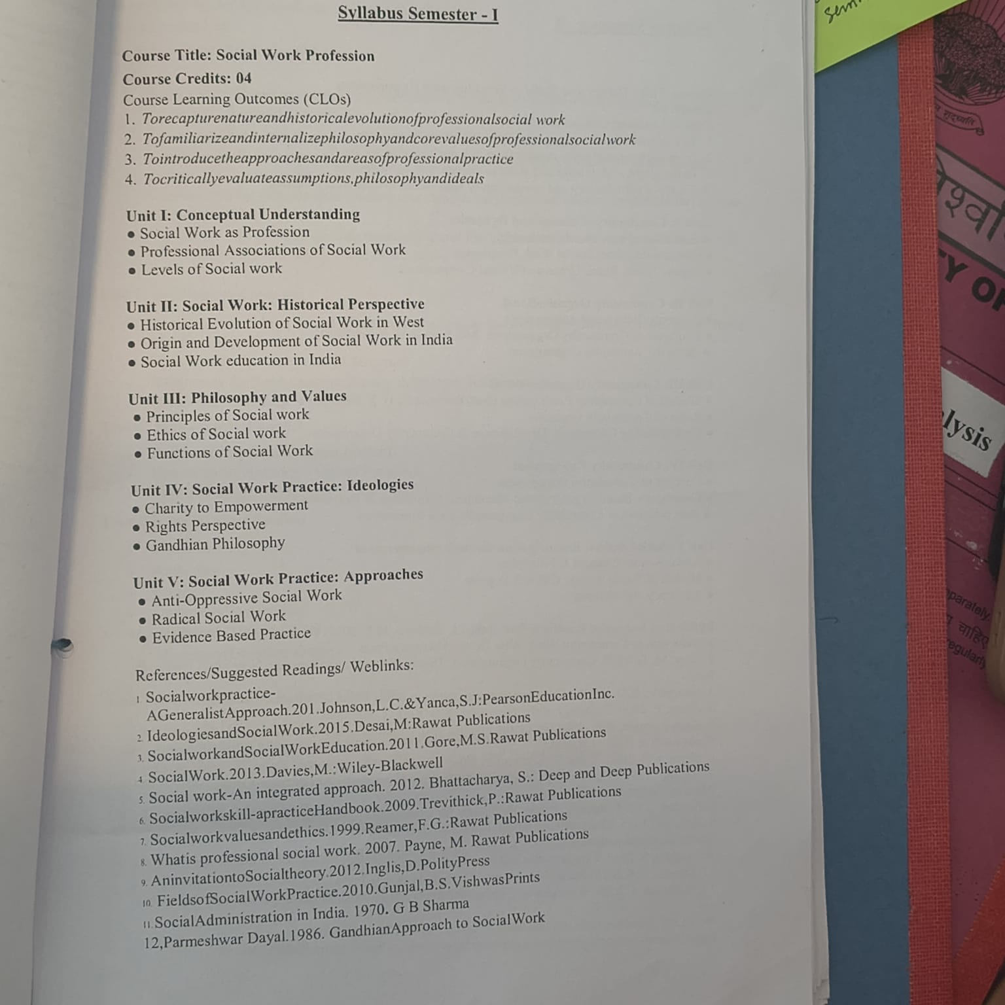

Lesson Plan
Lecture no | Topic Covered | Status
1 | Profession: Concept and Characteristics | Achieved
2 | Social Work as a Profession | Achieved
3 | Definition, Objectives, | Achieved
4 | Assumptions and Misconceptions | Achieved
5 | Methods, Process and Levels of Social Work | Achieved
6 | Human Rights | Achieved
7 | Social Justice | Achieved
8 | Social Welfare | Achieved
9 | Liberation and Empowerment | Achieved
10 | Social Policy | Achieved
11 | Historical Evolution of Social Work in UK | Achieved
12 | Historical Evolution of Social Work in USA | Achieved
13 | Origin and Development of Social Work in India | Achieved
14 | Role of Social Reform Movements in India | Achieved
15 | Role of Social Reform Movements in India | Achieved
16 | Professional Associations of Social Work | Achieved
17 | Development of Social Work Practice: | Achieved
18 | Charity to Empowerment | Achieved
19 | Principles of Social Work | Achieved
20 | Ethics and Values of Social Work | Achieved
21 | Social Work Functions | Achieved
22 | Gandhian Philosophy | Achieved
23 | Anti-Oppressive Social Work | Achieved
24 | Radical Social Work | Achieved
25 | Rights Perspective | Achieved
26 | Evidence-Based Practice | Achieved
27 | Feminist Practice | Achieved
28 | Enhancement of Quality of Life | Achieved
29 | Activism and Capacity Building | Achieved
30 | Revision | Achieved
31 | Revision | Achieved
32 | Revision | Achieved
33 | Revision | Achieved
34 | Revision | Achieved
35 | Revision | Achieved
36 | Revision | Achieved
37 | Revision | Achieved
38 | Revision | Achieved
39 | Revision | Achieved
40 | Revision | Achieved

Social Work Profession - Question Paper
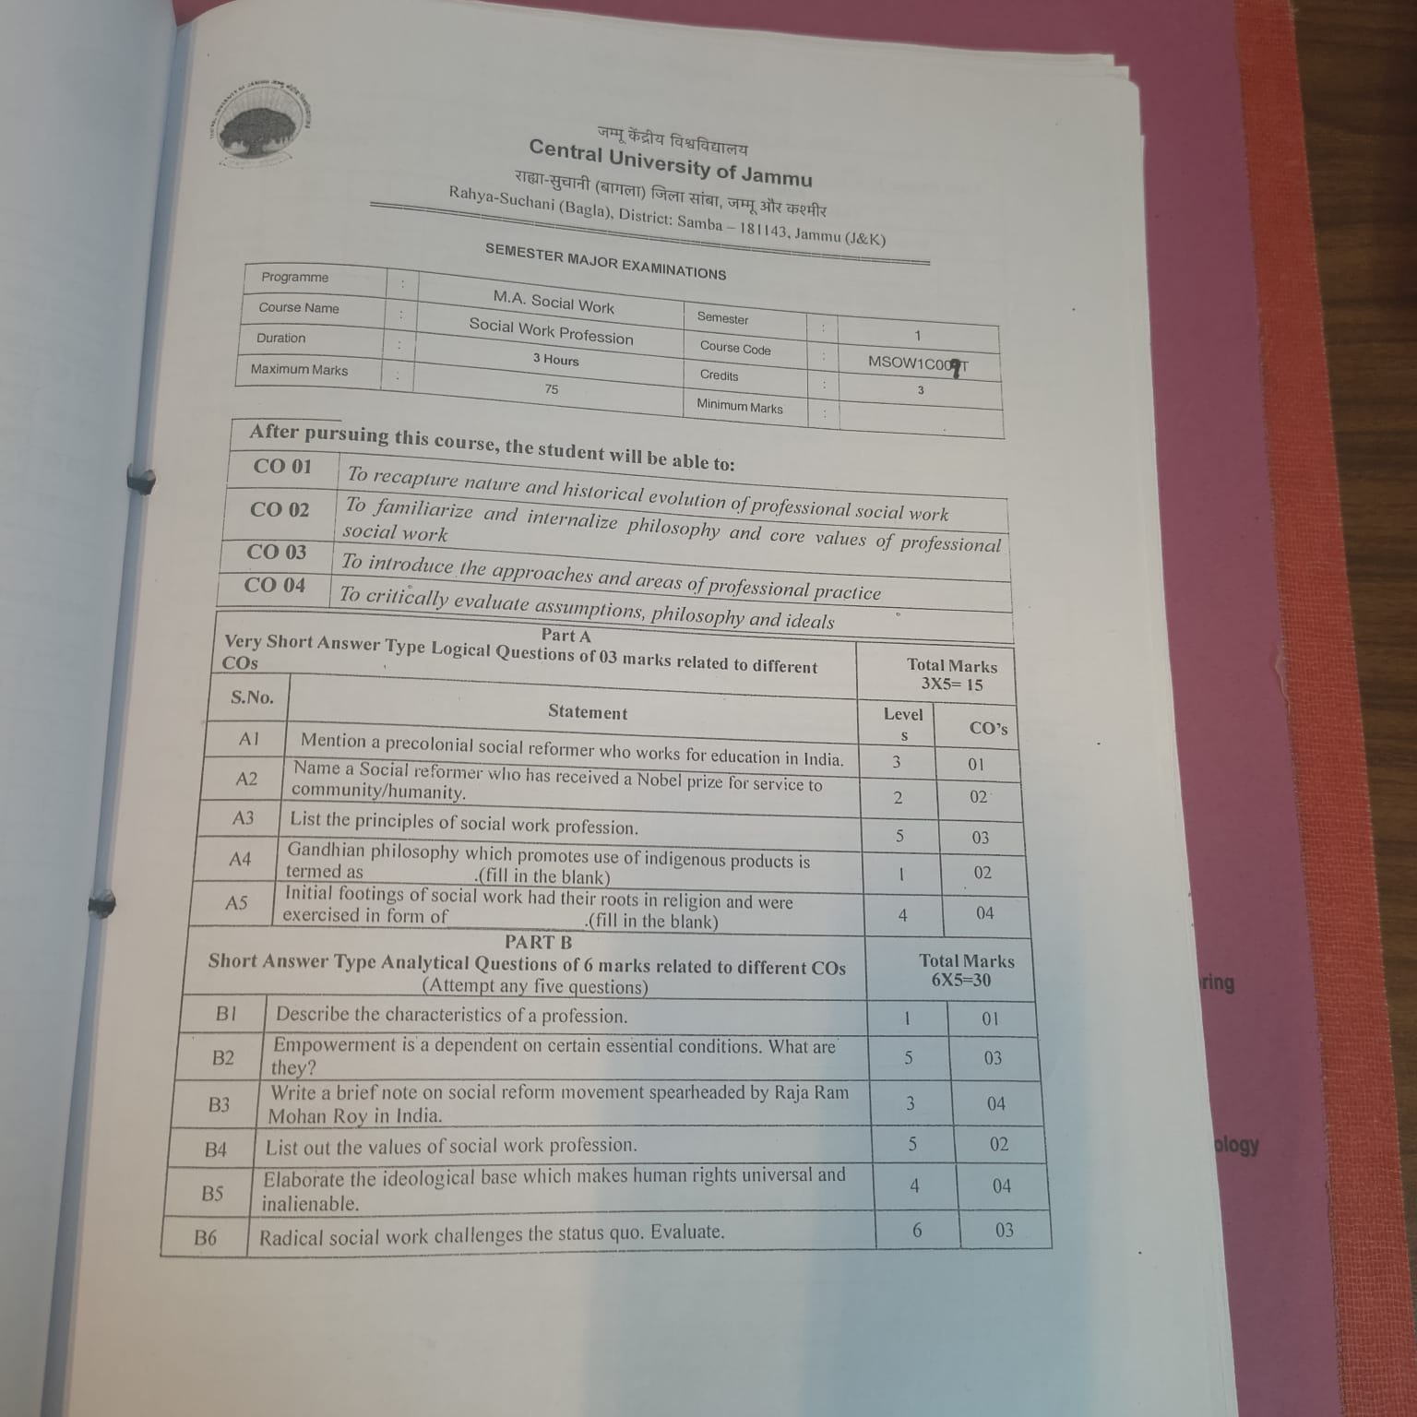

Learning Material
Overview: This document provides a brief overview of Solution-Focused Therapy (SFT), highlighting its principles, ingredients, practices, interventions, and applications in a client-centered, brief-therapy context.
Introduction and Objectives SFT is a brief, strength-based therapy emphasizing future goals over past problems. It aims to help clients construct solutions by focusing on their resources, successes, and desired outcomes. The objectives include understanding the rationale, key ingredients, practice principles, interventions, and applications of SFT.
Origin and Core Principles Developed in family therapy by Steve de Shazer, Kim Insoo Berg, and colleagues, SFT differs from traditional approaches by minimizing focus on past failures and emphasizing clients’ existing strengths and successes. Its core tenets include solution building rather than problem solving, focusing on the client’s desired future, and recognizing that small changes can lead to significant progress. It assumes solution behaviors already exist within clients and that change is constant and inevitable. The approach encourages clients to continue effective behaviors and to do something different if current strategies fail, keeping therapy simple and goal-oriented.
Ingredients of SFT The therapy involves conversations centered on client concerns, future visions, exceptions to problems, strengths, and resources. Key active ingredients include developing a cooperative alliance, setting measurable goals, focusing on future-oriented questions, scaling progress, and exploring exceptions where problems are less severe or absent. Therapists use specific techniques like the miracle question, scaling questions, reframing, and exception seeking to facilitate solution construction and motivate clients.
Practice and Treatment Principles The therapist’s role is to help clients identify and utilize their strengths, recognize exceptions, and focus on solutions. Building rapport through validation and a warm, accepting relationship is essential. The therapist adopts a learning stance, encouraging clients to teach their worldview, and avoids fixed session counts, instead assessing progress collaboratively. Negotiating a clear focal issue enhances motivation and efficiency, with the therapist guiding clients to articulate their goals and leverage solvable problems.
Interventions Common interventions include pre-session change (noticing improvements before therapy begins), exception seeking (identifying times when problems are less present), competence seeking (highlighting client strengths), the miracle question (visualizing a problem-free future), scaling questions (measuring progress and motivation), and reframing (finding alternative perspectives). These techniques are flexible and used according to the therapist’s judgment to facilitate rapid, client-driven change.
Compatibility and Target Populations SFT can complement other therapies, encouraging clients to continue effective treatments like medication or family therapy. It is suitable for diverse populations, including adolescents and adults, especially those with externalizing behaviors or academic issues. While effective for many, clients with severe psychiatric or medical conditions may require additional support, with SFT serving as part of a comprehensive treatment plan.
Summary SFT emphasizes exploring clients’ preferred futures and existing solutions, using respectful curiosity and strategic questioning. It promotes brief, goal-focused work that leverages clients’ strengths and resources, making it adaptable across various settings and populations. The approach advocates simplicity, small incremental change, and the belief that change is ongoing and achievable through collaborative effort.

STRENGTHS BASED PRACTICE:
PHILOSOPHY AND PRINCIPLES
Philosophy of Strengths based approach
It is a philosophy and a way of viewing clients as resourceful and resilient
in the face of adversity. It is also considered a method of practice, although
there is no strengths-based model of practice. People are resourceful and are
capable of solving their own problems. Unlike other approaches, it does not
give very high importance to weaknesses, limitations, and problems. In strengthsbased
approach, in contrast, the worker, in collaboration with the client system,
identifies and strengthens existing client system as well as capacities to resolve
problems and improve quality of life.
The essential assumption of the strengths based practice is that "every person
has an inherent power that may be characterized as life force, transformational
capacity, life energy, spirituality, regenerative potential and these are said to
be the "healing power", which is the potent form of insight that can help the
individual and group for their personal and social transformation This power
also means that people "possess the inherent capacity to learn, grow and develop."
Principles of Strengths based Practice
There are 10 principles of strengths based practice. It is not just a model
but rather it is a practice though with principles, ideas and techniques.
● A complete belief that every person has potential and that is unique
strengths.
● People are recognized as having much strengths and have the capacity
to continue to learn, grow and change.
● The focus of intervention is on the strengths and aspirations of the people
we work with.
● Communities and social environments are seen as being full of resources.
● Service providers collaborate with the people they work with.
● Interventions are based on self-determination

