Seminar on “ Unsung Indian Women Heroes of Freedom Struggle” Inaugurated Padmashri Shiv Nirmohi felicitated at CUJ
“Reading, Travelling and Seminaring enhances your acumen” – advises Padmashri Nirmohi to youngsters

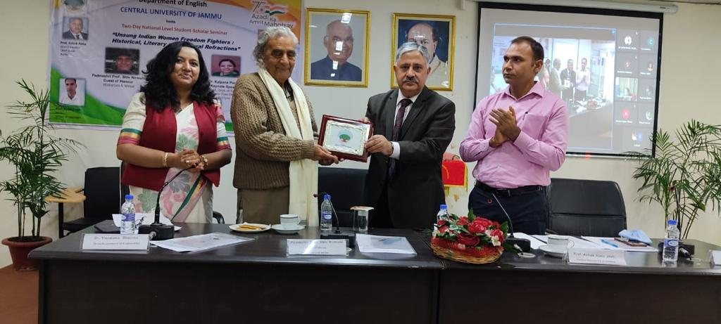

Padmashri Nirmohi ji felicitated by Prof. Aima
Carrying forward the ongoing celebrations of the glorious history of commemorating the 75 years of Independence of progressive India, a national level student-scholar seminar on “ Unsung Indian women Freedom fighters: Historical, Cultural and Literary Refractions”, organised by Department of English, Central University of Jammu was inaugurated in the university campus on 22 November, 2021 by the Vice Chancellor, Prof. Ashok Aima and Padmashri Shiv Nirmohi in the Brigadier Rajinder Singh auditorium. The seminar planned in a blended mode was also joined by Prof. Neeraja Gupta, Vice Chancellor, Sanchi University of Buddhist-Indic Studies, who highlighted the significance and timeliness of the theme of the seminar particularly the cultural and literary perspective of unsung women freedom fighters as narratives pertaining freedom struggle get limited only to historical narratives. In her address, Prof. Neeraja underscored how dating for freedom movement needs to be deliberated with special thrust on women like Jhalkari and many others in her women contingent who fought during the First War of Independence. In the Inaugural address, Prof. Aima said that seminars on such themes related to representations, adaptations pertaining our culture and heritage is imperative and the switch over from virtual to physical mode is a welcome move. Speaking on the occasion, Prof. Rasal Singh, Dean, School of Languages threw light on documenting the contributions of unsung freedom fighters and expressed hope that Department of English will work in the same direction with gusto.
Padmashri Shiv Nirmohi, an eminent litterateur, historian and icon of Dogra pride was felicitated by Prof. Aima in the same function. Speaking on his literary journey, Padmashri Nirmohi advised younger generation to read, travel and participate in seminars to expand horizons of learning. Shedding light on the strength and exemplary courage of Duggar women, Padmashri Nirmohi referred to the resilience and courage of Naraatu Devi, whom Dinu Bhai Pant has glorified in his poetry as “ Sherni Naraatu”. Earlier, welcoming the guests, Dr. Vandana Sharma, Head, Department of English and convener of the seminar said that in sync with the aim of the semina,r a good number of papers exploring various forms of narratives related to lost narratives of women freedom fighters hint at gaps in history and raises the question related male-centric post 1947 historical records. Prof. Kalpana Purohit, Head Department of English, Jai Narayan Vyas University, Jodhpur in her keynote address traced the trajectory of freddom struggle and women’s role in it with special emphasis on Rajasthan. Another noted speaker of the seminar was Prof. Neeraja Matto, Kashmiri writer and scholar eminent for her research in the Kashmiri narratives and story telling. Dr. Parveen Kumari proposed vote of thanks.

