Three Day Workshop on ‘Digital Literacy & Skill Building of Rural Women Entrepreneurs’ under UNESCO Project concludes

Three day workshop was organized by Central University of Jammu in collaboration with National Rural Livelihood Mission (NRLM) for building digital skills of rural women entrepreneurs. The workshop was organized under the UNESCO project (IFAP programme), the only project in India being sanctioned to the faculty of Central University of Jammu under the aegis of H’ble Vice Chancellor, Prof Sanjeev Jain. The workshop was attended by more than 100 Rural Women Entrepreneurs representing each district and block of Jammu Division. The main focus of the workshop was train the participants as master trainers and build their digital capacities for further training rural women entrepreneurs with the aim of boosting their business with the use of emerging technologies.
The workshop started with the inaugural ceremony which was marked by the gracious presence of the chief guest Ms. Prerna Puri IAS, Commissioner Secretary, IT Department, Government of J&K who appreciated the efforts of the Project Directors towards empowering the SHG women by building their digital skills. Sh, Abhishek Sharma IAS, Deputy Commissioner, District Samba, emphasized the importance of community-academia partnership in training and handholding of rural women entrepreneurs. It is pertinent to mention here that in collaboration with J&K Rural Livelihood Mission (JKRLM), Department of Rural Development, Government of J&K, the workshop contributed towards Digital India Mission and Vocal for Local campaign by building the capacities of master trainers to showcase and brand their products by using latest apps and features on the phones. Ms. Indu Kanwal Chib, JKAS, Mission Director, JKRLM, J&K in her address inspired the trainees to cover extra mile to get maximum benefit from the workshop. The training handbook was also inaugurated in the inaugural ceremony.
The various sessions of the workshop included the hands on training of digital literacy, scheduling online meetings, digital hygiene, creating and protecting passwords, undertaking online transactions, browsing the web safely, protecting personal and finance related information, detecting suspicious website, designing logo, starting their own company,, Gem portal, digital marketing and improving social media presence of their business.
The valedictory session was graced by Ms. Indu Kanwal Chib, JKAS, Mission Director, JKRLM, J&K, Prof. Vandana Sharma, Dean Languages, Central University of Jammu and Registrar of the University Prof. Yashwant Singh. The workshop concluded with the distribution of certificates to the participants.
The directors of the coveted Project are- Dr. Ritu Bakshi from Department of Education Studies, Dr. Bharti Gupta, Department of Tourism and Travel Management, Dr. Archana Kumari, Department of Mass Communication and Dr. Nancy Mengi, Department of Social work.

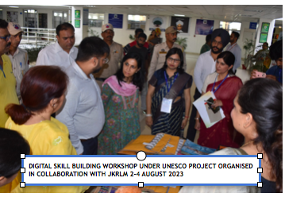
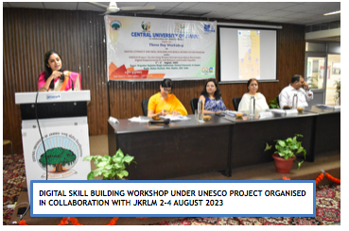
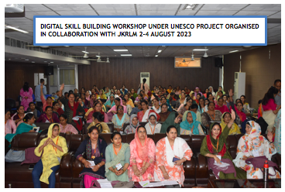
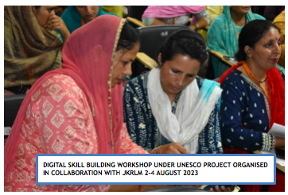

DIGITAL SKILL BUILDING WORKSHOP UNDER UNESCO PROJECT ORGANISED IN COLLABORATION WITH JKRLM 2-4 AUGUST 2023

DIGITAL SKILL BUILDING WORKSHOP ORGANISED FOR RURAL WOMEN UNDER UNESCO PROJECT

2-4 AUGUST, 2023

