Department of Economics
Central University of Jammu
राया-सूचानी(बागला), जिलासांबा -181143,जम्‍मू (जम्‍मूएवंकश्‍मीर)
Rahya-Suchani (Bagla), District Samba-181143, Jammu (J&K)

Batch : 2022-2024
S.No. | Student Name | Roll No | Email ID/Address | Photo
1 | Zaffar Ahmad Dar | 22MECO02 | darzaffar07@gmail.com  DRUROO, BARAMULLA, J&K.
2 | Ankita Choudhary | 22MECO04 | ankitachoudhary277@gmail.com  VILLAGE - PARDHI , P/O. RAMGARH , TEH. RAMGARH, SAMBA, J&K. | 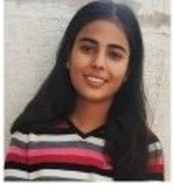
3 | Rachna Devi | 22MECO05 | rachnathappa65@gmail.com  SAMOLE, UDHAMPUR, J&K. | 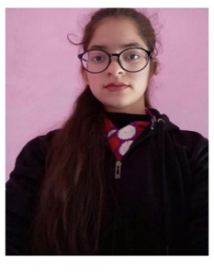
4 | Sahil kumar | 22MECO07 | sahilkumar62002@gmail.com  VILLAGE POST YOUVRAJPUR, GHAZIPUR, UTTAR PRADESH. | 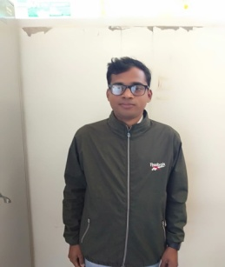
5 | Shantun Sharma | 22MECO10 | shantunsharma72@gmail.com  596-B NAIBASTI JAMMU, J&K. | 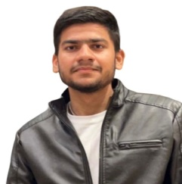
6 | Srijon Kumar Saikia | 22MECO11 | srijon.saikia@gmail.com  HOUSE NO 18, BANFUL PATH, BANFUL NAGARH, DISPUR, LASTGATE, GUWAHATI, Assam | 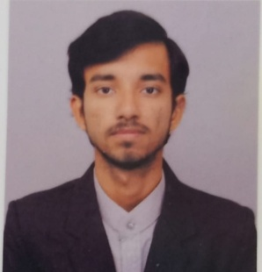
7 | Shalu Sharma | 22MECO12 | mansotrashalu@gmail.com  VILLAGE KANAH PO DALSAR TEHSIL RAMNAGAR, UDHAMPUR, J&K. | 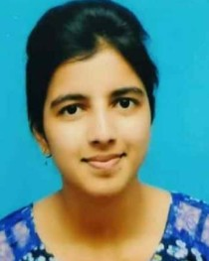
8 | Anees Rashid | 22MECO13 | aneesrashid78@gmail.com  PHALNI, RAJAURI, J&K. | 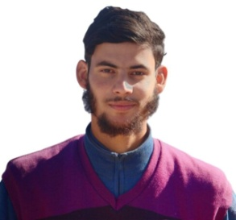
9 | Avinash | 22MECO15 | avinashdogra63@gmail.com  36, PATTA, REASI, J&K. | 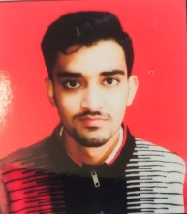
10 | Zakir Hussain | 22MECO16 | zakirlucky8217@gmail.com  DRASS, KARGIL, LADAKH, J&K. | 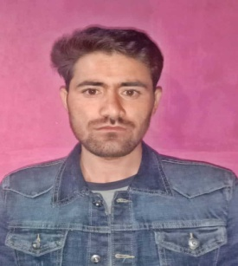
11 | Imran Hanief | 22MECO17 | imranhanief1@gmail.com  AZAMABAD, POONCH, J&K. | 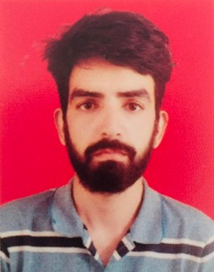
12 | Anjali Sharma | 22MECO18 | anjali454566@gmail.com  LAMMAN BHAJWAL,SUNDERBANI, RAJOURI, J&K. | 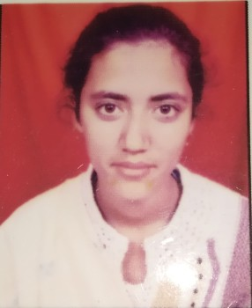
13 | Vishakha Thakur | 22MECO19 | Vishakhat507@gmail.com  ANANTH NALLA, KISHTWAR, J&K. | 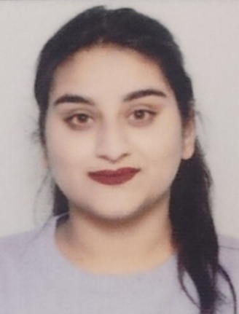
14 | Rashi  Sharma | 22MECO20 | srashi042@gmail.com  W. NO. 6 H NO 14 VIJAYPUR, SAMBA, J&K. | 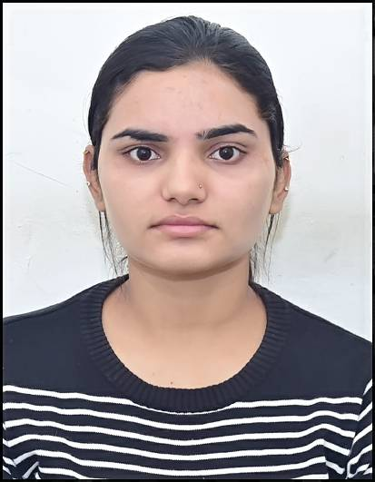
15 | Janhavi Chohan | 22MECO21 | janhavichohan@gmail.com  H.NO.86, KUCCHA NAR SINGH GALI, PANJTIRTHI,Jammu, J&K. | 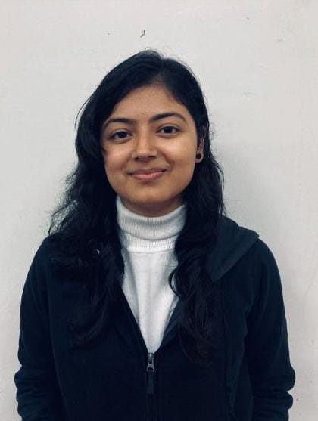
16 | Mohd Asif | 22MECO22 | asifrather0786@gmail.com  GANDOH BHALESSA , INHARRAH, DODA, J&K. | 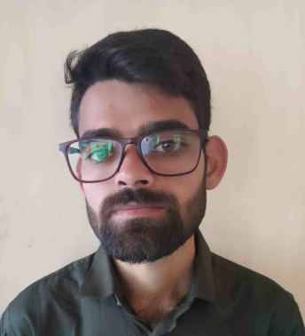
17 | Smile sharma | 22MECO23 | smilesharma411@gmail.Com  WARD NO 67 NEAR RAM MANDIR MUTHI PO MUTHI TEHSIL JAMMU NORTH, J&K. | 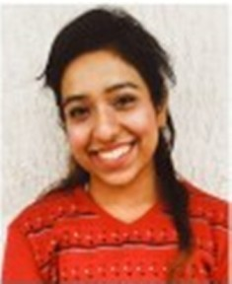
18 | Shuriti Sharma | 22MECO25 | shrutisharma365ss@gmail.com  40, DHANWA, REASI, J&K. | 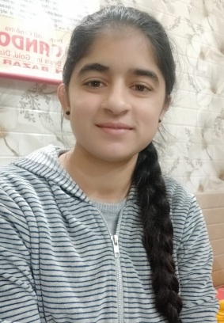
19 | Shaheena anjum | 22MECO26 | anjumshaheen806@gmail.com  KANOOR, KARGIL, LADAKH. | 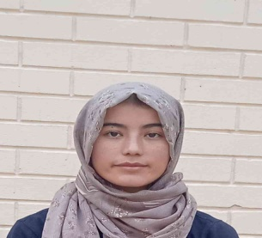
20 | Jagriti Katoch | 22MECO27 | jagritikatoch37@gmail.com  BASHAT, TEH. CHENANI, UDHAMPUR, J&K. | 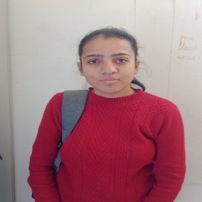
21 | Shruti Sharma | 22MECO28 | shrutisharma80608@gmail.com  40, DHANWA, REASI, J&K. | 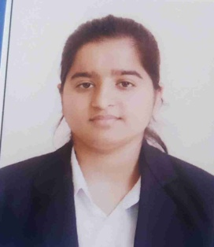
22 | Akanksha Baloria | 22MECO29 | akankshabaloria51@gmail.com  Lane No 9 Friends Colony Gurha Brahamana, Jammu, J&K. | 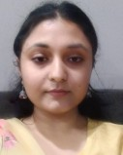
23 | Hardeep Singh | 22MECO30 | hardeepsingh7625@gmail.com  VPO QILA DARHAL, RAJOURI, J&K. | 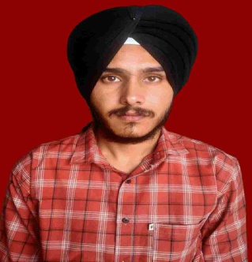
24 | Ansh Arora | 22MECO31 | ansh08arora@gmail.com  4A II Extn, Gandhi Nagar Jammu, J&K. | 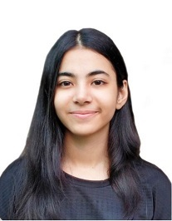
25 | Anjali Verma | 22MECO33 | av373499@gmail.com  CHHAN MATLONI TEH GHAGWAL DIST SAMBA, J&K. | 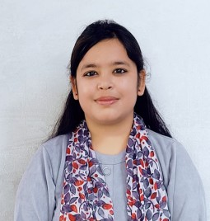
26 | Pinkey Devi | 22MECO34 | bhagatpinkey92@gmail.com  VILLAGE SENCHA DISTT RAMBAN, J&K. | 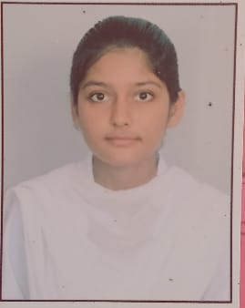
27 | Tania Mehra | 22MECO35 | taniamehra2512@gmail.com  HOUSE NO 109 WARD NO 7 BISHNAH | 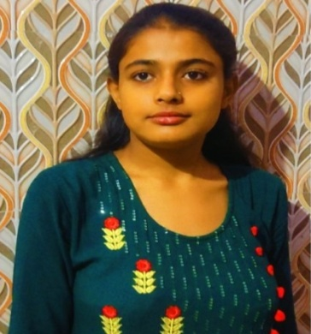
28 | Riya Sharma | 22MECO36 | riiyaasharma448@gmail.com  C-106 LANE NO 11, LOWER SHIV NAGAR JAMMU, J&K. | 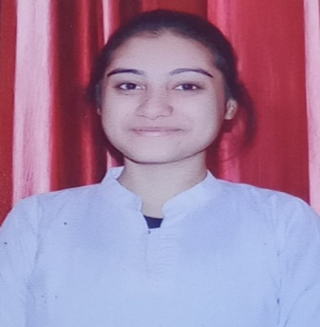
29 | Sonali sharma | 22MECO37 | sonalisharma45796@gmail.com  HOUSE NO 31 WARD NO 11 BISHNAH, J&K. | 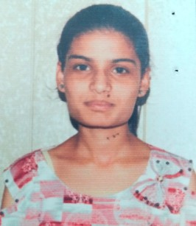
30 | Farida batool | 22MECO38 | Faridabatul7@gmail.com  BAGH - E-KHOMENI KARGIL LADAKH 194103 | 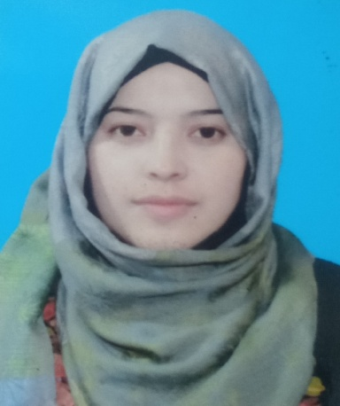
31 | Shahroon Tabassum | 22MECO39 | shahroontabassum618@gmail.com  R/O PHALNI P/O SAMOTE TEH KOTRANKA DIST RAJOURI 185233, J&K. | 