School of Business Studies, CUJ initiates International Lecture Series
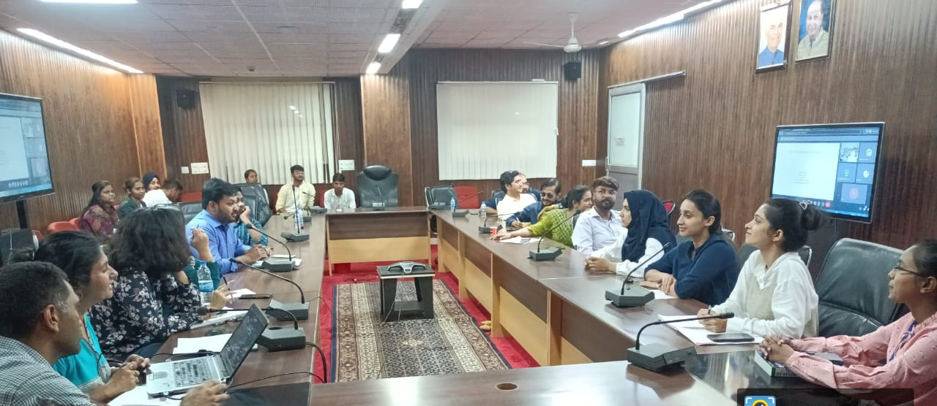
In pursuit of expanding their knowledge expanse and upgrading the key conceptualizations of management, The Department of Marketing & Supply Chain Management in collaboration with Department of HRM & OB, School of Business Studies, Central University of Jammu initiated International Lecture Series with a global line up of speakers who are stalwarts in their respective fields. In order to cater to the dynamic needs of the business environment, School of Business Studies endeavoured to cross the national boundaries in an attempt to impart holistic exposure to its students, scholars and the teaching fraternity.
The international lecture series initiated with the welcome address by Prof. Jaya Bhasin, Dean, School of Business Studies, CUJ. The first esteemed speaker for the series was Prof. Vithala R. Rao from Samuel Curtis Johnson Graduate School of Management, Cornell University, New York. Professor Rao comes with a rich teaching & research experience of more than five decades and holds expertise in marketing and quantitative methods and. His deliberation on the topic, ‘Product Bundling & Consumer Choice’ was greatly applauded by the teaching fraternity together with research scholars and students. Research scholars took immense interest in learning the nuances of ‘Product bundling research’ through the examples explained by Prof. Rao. The lecture was conducted in blended mode under the able leadership of Prof. Sanjeev Jain, Vice Chancellor, Central University of Jammu and under the supervision of Prof. Jaya Bhasin, Head, Department of HRM & OB and Dr. Shahid Mushtaq, Head, Department of Marketing & Supply Chain Management conceptualized this event. Dr. Salil Seth and Mr. Asif Ali from School of Business Studies, CUJ coordinated the event. The first deliberation of the international lecture series ended with a vote of thanks by Mr. Asif Ali.

