NCC Unit of Central University of Jammu Celebrated73rd NCCDayon 28th November2021
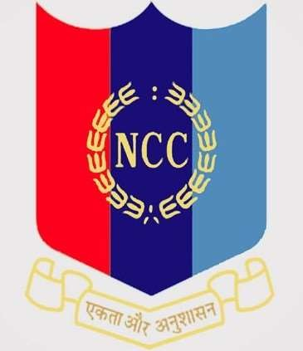
Jammu 28 November 2021: The NCC unit of Central University of Jammu celebrated 73rd NCC day in the virtual mode on the online Google platform. The event was organised by the Cadets under the patronage of our CT/ ANO Dr. Pankaj Mehta, with full of enthusiasm and the feeling of patriotism. The event started with the recitation of the national anthem.
Cadet Amit Anand coordinated the event by reciting a patriotic poem, followed by Cadet Daler Khan who shared some views on importance and scope of NCC among the youth. Cadet Nikhil Pikhen spoke about the adventurous trainings and

Certificate exams conducted by the NCC unit. Finally Cadet Shubham Sharma gave presentation on the History, Motto and Aim of the NCC unit. He also explained the structure of NCC among the fellow Cadets of the Central University of Jammu.
While speaking on the occasion CT/ANO Dr. Pankaj Mehta laid the emphasis on raising the awareness about the importance of NCC in Youth and every cadet should understand his own responsibility. He also briefed about the role of NCC in National Education Policy 2020. The inclusion of NCC as an elective course in the University course curriculum will definitely help in shaping the cadets for a better future.
The National Cadet Corps (NCC), is the youth wing of the Indian Armed Forces and the largest uniformed youth organisation in the world, celebrates the 4th Sunday every year in the month of November as NCC day throughout the country where cadets participates in blood donation camps and rallies.
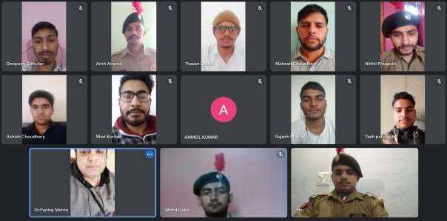
Snapshot: Celebration of 73rd NCC day by NCC Unit of Central University of Jammu in virtual mode.

